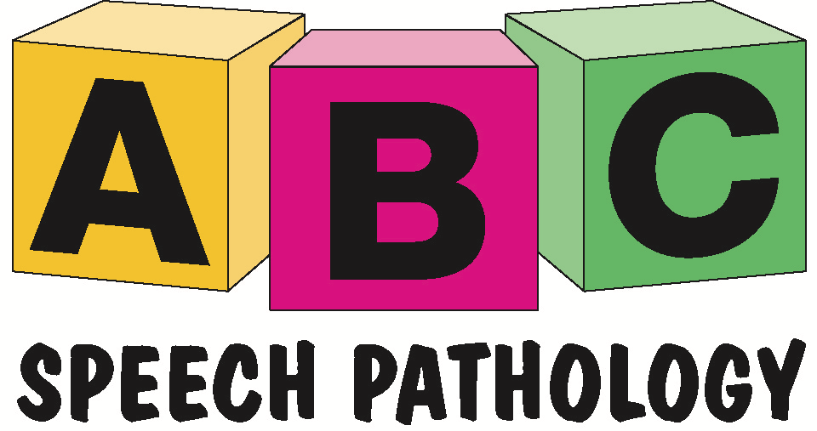

Policy and Procedures

POLICY NAME | COMPLAINTS & FEEDBACK
POLICY NUMBER | 18
START DATE | 1.12.20
REVIEW DATE | 1.12.22

PURPOSE

The purpose of this policy is to establish mechanisms for clients and family members, carers, and advocates to provide feedback to ABC Speech Pathology, or, to lodge a complaint or grievance. ABC Speech Pathology promotes the rights of all clients and client’s families to raise and discuss concerns about services provided by ABC Speech Pathology Therapists.

POLICY STATEMENT

Clients or client’s families are able to raise concerns without fear of adverse consequences. All feedback or complaints will be addressed in writing (within 7 days) and feedback will be used to review current services and implement service improvements. The policy has been framed around natural justice principles and individuals’ rights as they are specified in the Standards Australia Complaint Handling Standard (As4269)-(1995), The Disability Services Act (1993) and the NDIS Practice standards (2020) which states “Each participant has knowledge of and access to the providers complaint management and resolution system. Complaints and other feedback made by all parties are welcomed, acknowledged, respected and well managed.”
ABC Speech pathology is committed to ensuring that all its clients and their families/carers are free to lodge grievances, to have them dealt with promptly, fairly and non-threateningly, and to have those grievances resolved if possible. Treatment of disputes and grievances will be fair to both complainant and respondent, will be responded to courteously and will be given high priority for resolution and remediation.

PROCEDURES

This policy describes how ABC Speech Pathology will manage and respond to concerns or complaints. ABC will inform clients, families/carers that feedback about the service is welcomed, and inform them of how they can provide feedback at any time. A copy of this policy should be available on ABC speech Pathology’s website at all times.

1. If a person has a complaint or concern, in the first instance they should be encouraged to resolve the issue with the person concerned; that is, the staff member or volunteer with whom they have an issue to be resolved.

2. Upon receipt of a complaint the staff member will review and respond to the complaint in writing within 7 days.

Complaints can be made by;

Phone 0433100561 – Details of the complaint will be recorded and a written response will be provided within 7 working days.

Online Feedback and Complaints-
https://www.abcspeechpathology.com/contact

3. If you are not satisfied with the outcome of the discussion, you can contact SPA (Speech Pathology Australia) to report your concern and lodge a formal complaint.
https://www.speechpathologyaustralia.org.au/SPAweb/Resources_for_the_Public/Making_a_Complaint/SPAweb/Resources_for_the_Public/Make_a_Complaint/Making_a_Complaint.aspx?hkey=6b603c7c-33ec-4845-8b3f-d43b22909465

Speech Pathologists are required to abide by the Speech Pathology Code of Ethics.
https://www.speechpathologyaustralia.org.au/spaweb/Document_Management/Public/Ethics.aspx

NDIS PARTICIPANTS

NDIS registered Providers are required to abide by the NDIS Code of Conduct.
https://www.ndiscommission.gov.au/document/811

4. If you are not satisfied with the outcome of your discussion with the service provider, you can contact the NDIS to make a complaint. https://forms.business.gov.au/smartforms/servlet/SmartForm.html?formCode=PRD00-OCF

